Pet Show
Steward: Jill Kelly – 0428 334 459
Start Time: 11am Wednesday 27th May
Entry: 50c
Proudly Sponsored by North West Vets Coonamble &
Miss Jillian Kelly
Dogs must enter and exit through the southern end of the grounds.
All pets must be on a leash at all times
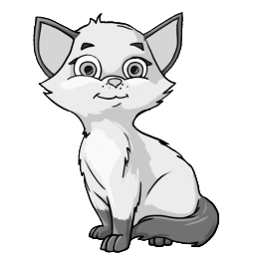
1. Biggest Pet
2. Smallest Pet
3. Hairiest Pet
4. Cutest Pet
5. Hungriest Dog
6. Pet that looks like it’s Owner
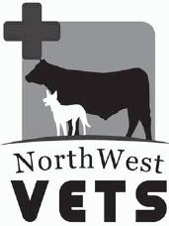
7. Waggiest Tail
8. Longest Sausage Dog
9. Best Trick
10. Most Unusual Pet
11. Best Dressed Pet
Champion Pet of the Show

