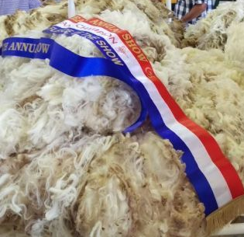
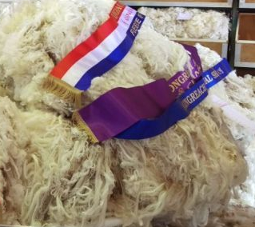
WOOL
Stewards: Richie Markey: 0427 253 378
Brendan O’Connor: 6822 2517

- Wool to be delivered to the Pavilion on Saturday 23rd May (or left at Landmark / Elders) to allow time for weighing prior to judging commencing at 8.30 am the First Day of the show.
- Absolutely NO wool will be accepted AFTER 9.00am the First Day of the show. No Exceptions
- All wool is to be labelled clearly with full particulars, including complete name of owner (no initials), and properties
- Fleeces to be classified by owner prior to delivery to show
- The judge has the right to reclassify any fleeces
- All fleeces to be skirted as for market
- Fleeces not to be more than 12 months growth
- Fleeces other than those from classes 7 & 8 must not be from housed or rugged sheep
- Fleeces from exhibitors who breed Rams for sale will be judged in Class 7 & 8
- Ram wool is excluded from commercial value classes
- Commercial value fleeces may not be shown in classes 1-8
- Best pair of fleeces will be judged on uniformity not individuality
- Fleeces eligible for Local Exhibitors trophy must be from stock owned and bred by the exhibitor in local show area
- The fleece will remain the property of the exhibitor
- Any fleece not collected by 5pm on the second day of the show will be deemed DONATED (no responsibility will be accepted) unless arrangements are made specifically with stewards
- Thank you to all exhibitors who participate to help make a successful show

Classes

- Fine Ewe or Wether Fleece, Merino
- Medium Ewe or Wether Fleece, Merino
- Strong or extra Strong Ewe or Wether Fleeces Merino.
- Best pair or Ewe or ether fleeces(fine, Medium, Strong or extra Strong)
- Medium Ram Fleece, Merino
- Strong or extra strong Ram Fleece, Merino
- Stud or Housed Ewe Fleece, any quality, Merino
- Stud or Housed ram Fleece, any quality, Merino

Merino Commercial Value Section
9. Fine Ewe or Wether Fleece, Merino
10. Medium Ewe or Wether fleece, Merino
11. Strong or extra strong Ewe or Wether Fleece, Merino

Border Leicester
12. Border Leicester Ewe Fleece

Dohne Fleece
- Unhoused Ram fleece
- Best Ewe or Wether Fleece
- F1 Ewe or Wether Fleece
- F2 Ewe or Wether Fleece

The Dohne section sponsored by Calga Dohnes www.calga.biz

Prizes: Classes are Judge via a point score system

Local Exhibitor

Most Successful local Flock Merino Exhibitor
Classes 1, 2, 3 & 4
James Ballard Memorial
Champion Local Fleece
Point Classes 1, 2,3,5,6,12 & 13
Sponsored by SARUMAN PTY

Open Exhibitors

Most Successful Exhibitor
Classes: 1,2,3,4,5,6,7,8,10,11,12
Sponsored by Don McDonald Wool

Reserve Grand Champion Fleece
Sponsored by Don McDonald Wool

Grand Champion Fleece
highest point score Classes 1,2,3,5,6,12
Sponsored by AJF Brien & Sons

Highest value Champion fleece ($/head)
Classes 1, 2 & 3 Proudly sponsored by SARUMAN PTY

Champion Fine Merino Fleece:
Class 1 Sponsored by Elders

Champion Medium Merino Fleece:
Class 2 Sponsored by Landmark
Champion Strong or Extra Strong Merino Fleece:
Class 3 Sponsored by Will Landers
Best Pair of Fleece:
Class 4 Sponsored by K & H Glover

Champion Merino Ram Fleece:
classes 4 & 5 Sponsored by Barrett Family

Champion Stud, Housed Merino Fleece:
Classes 7 & 8 Sponsored by Halcroft and Bennett
Champion Commercial Value Fleece:
Classes 9, 10 & 11 Sponsored by Halcroft and Bennett

