SHEEP SECTION
Showground PIC number:
NA171290
Wednesday 16th May 2018
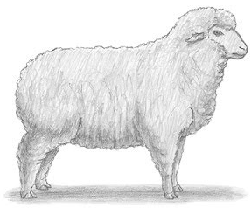
Conditions of Entry
Flock Merino – Steward: Simon Ibbott
- Sheep to be penned by 9am on the Second day of the show
- Exhibitors breeding rams for sale excluded from the section
- Competitors not restricted to distance from Coonamble
- Date of shearing to accompany entries.
- Sheep for this section to be taken straight from paddock and given only normal paddock grazing feed.
- Sheep for single entries may be drawn from pens
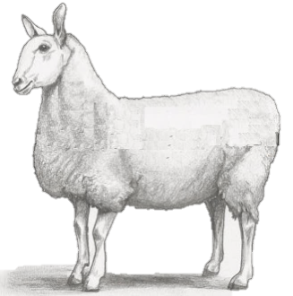
- Class 7 may not be drawn from class 8 and vice versa
- Shorn Classes – Shorn within 12 months of show

British Breeds – Steward: Brett Wilson
- Sheep to be entered by owner, except where stated
- All entries to be drawn from registered flocks.
- Border Leicester shorn sheep to have no more than 4cm of wool
- White Suffolk to have no more than 3cm of wool
- Current Footrot and Brucellosis Accredited Certificate – must be sighted prior to unloading.
- Perpetual Trophies always remains the property of the Coonamble Show Society Incorporated. Winner will hold the trophy for presentation to the next Coonamble show
Prime Lamb – Steward: Danny Keady
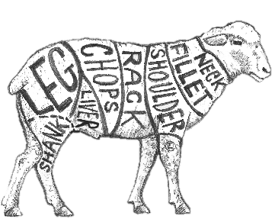
- Competitors enter at their own risk.
- Check with stewards for parking and unloading.
- Entries pens of 3
- All lambs to be penned by 9:30am
- All lambs must have milk teeth
- Entries to be weighed by stewards and put into classes
- Entries will be judged from 10.00am Wednesday
- All entries require sheep health statements
Coonamble Show Society inc. would like to thank all our valued Sponsors, Agents, Producers and Judges for their support in our 2018 Sheep Section.
Sponsors: -Ibbott Family, Wyuna Merino Stud, Town and Country Insurance Brokers Dubbo, Landmark, Elders Rural, Schute Bell Newcastle, C. Wilson, Brigendoone Perpetual Trophy, Charlie Nixon Perpetual Trophy,
Dennis Todd, Jackson Freightliners, Karoona Park Stud, Stratton Family.

FLOCK MERINO SHEEP
Steward: Simon Ibbott - 68256208
Entry fee $2 for each class
Conditions – See Sheep Section Cover Page
Shorn Classes – Shorn within 12 months of show

Medium Wool
- Ewe, 2 tooth, milk tooth eligible
- Ewe, 4 tooth
- Ewe, 6 or 8 tooth
Champion and Reserve Champion Medium Wool Ewe
Strong Wool
- Ewe, 2 tooth, milk tooth eligible
- Ewe, 4 tooth
- Ewe, 6 or 8 tooth
- Champion 2 Tooth Ewe

Champion and Reserve Champion Strong Wool Ewe
Grand Champion Flock Merino Ewe
Trophy & $150 Proudly Donated by Wyuna Merino Stud

- Pen of 3 Merino Ewes
Any age any shearing to be judged on confirmation and evenness of wool type
$100 prize proudly sponsored by the Ibbott family

BRITISH BREEDS
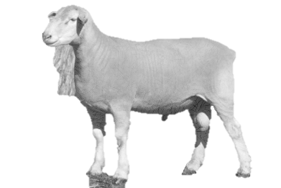
Steward: Brett Wilson - 0268222518
Conditions – See sheep section cover page
BORDER LEICESTERS – WOOLLY CLASSES

- Ram, Over 1 year
- Ram, Under 1 year
- Pair of Rams under 1 year, woolly
- Ewe, Over 1 year
- Ewe, Under 1 year
- Pair of Ewes under 1 year, woolly

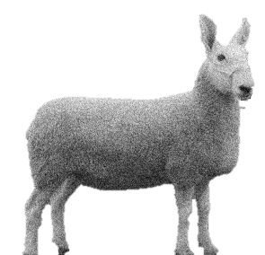
Champion & Reserve Champion Woolly Ram
Trophy donated by Town & Country Insurance Brokers, Dubbo
Champion & Reserve Champion Woolly Ewe
Trophy donated by Landmark

BORDER LEICESTERS- SHORN CLASSES

- Ram - Over 1 year
- Ram - Under 1 year
- Pair of Rams Under 1 Year
- Ewe - Over 1 year
- Ewe - Under 1 Year
- Pair of Ewes Under 1 Year

Champion & Reserve Champion Shorn Ram
Trophy donated by Elders Rural Services.
Champion & Reserve Champion Shorn Ewe
Trophy Donated by TBA

WHITE SUFFOLK

- Ram - Over 1 year
- Ram - Under 1 year
- Ewe - Over 1 year
- Ewe - Under 1 Year
Champion & Reserve Champion White Suffolk Ram
Trophy donated by TBA
Champion & Reserve Champion White Suffolk Ewe
Trophy Donated by TBA

Best Group Woolly Border Leicesters-One ram and two ewes not over one year old.
~The Brigendoone Perpetual Trophy F&I Cameron. & $150~
Best Group Shorn Border Leicesters-One ram and two ewes not over one year old.
~The Charlie Nixon Perpetual Trophy & $150~

Best Group Interbreed -One ram and two ewes not over one year old.
~Trophy Proudly Donated by Dennis Todd~

Junior Handlers - School Ages - 1st, 2nd 3rd Placing’s
Most Successful Exhibitor- Point System-1st 3 points, 2nd 2 points, 3rd 1 point, Champion 2 points, Reserve 1 point
~ Trophy Proudly Donated by Jacksons Freightliners

~GRAND CHAMPION RAM~
Proudly Sponsored by Castlereagh Stud Trophy: C Wilson

~GRAND CHAMPION EWE~
Proudly Sponsored by Schute Bell, Newcastle

PRIME LAMB COMPETITION

STEWARDS: Danny Keady: 0407298037
Entry fee: $5.00
LPA NATIONAL VENDOR DECLARATION AND ANIMAL HEALTH STATEMENT
Conditions: - See Sheep Section Cover Page

- Pen of three trade lambs 43-50kg Liveweight 1st prize ribbon
2nd prize ribbon

- Pen of three lambs 50.1kg Liveweight and over 1st prize ribbon
2nd prize ribbon

Champion & Reserve Champion Pen of Lambs
Ram Donated by Kanoona Park Stud,
Ribbon and Trophy donated by Stratton Family “Ninegear”
Champion & Reserve Champion Pen of Lambs
$100 Prize money and Ribbon

THE COONAMBLE SHOW SOCIETY WOULD LIKE TO THANK ALL THE SPONSORS, PRODUCERS, AGENTS AND JUDGES FOR SUPPORTING OUR SHEEP PAVILION.

